TEST SHEET
See the documents below and answer the following?

What is wrong with this adhar card?
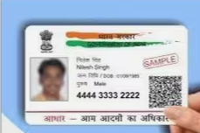
Adhar Card is Blur
What is wrong with this PAN card?
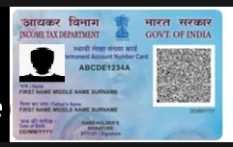
PAN Card Is Blur
Assuming today’s date is 01/04/2024, What is wrong with this electric bill? What a correct electric bill should be like, give a description of correct electric bill

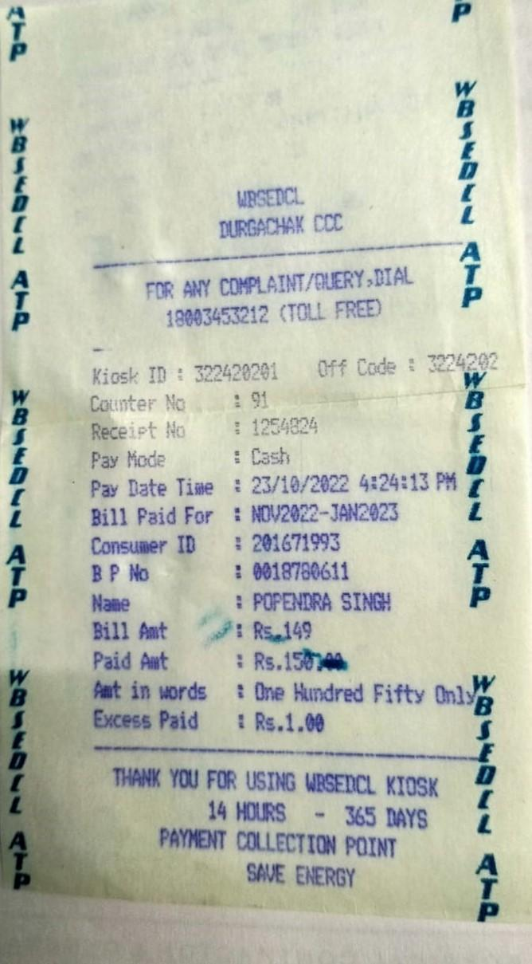
The Bill is 6 Month Old and this is not valid for the registration the bill should be not more than 45 days Old and it should be proper format as bill was coming to the Door

What is wrong with this pic?


In this picture the background should be White and should be straight towards the camera but in this picture photo was slightly tilted

What is wrong with this Bank Statement?
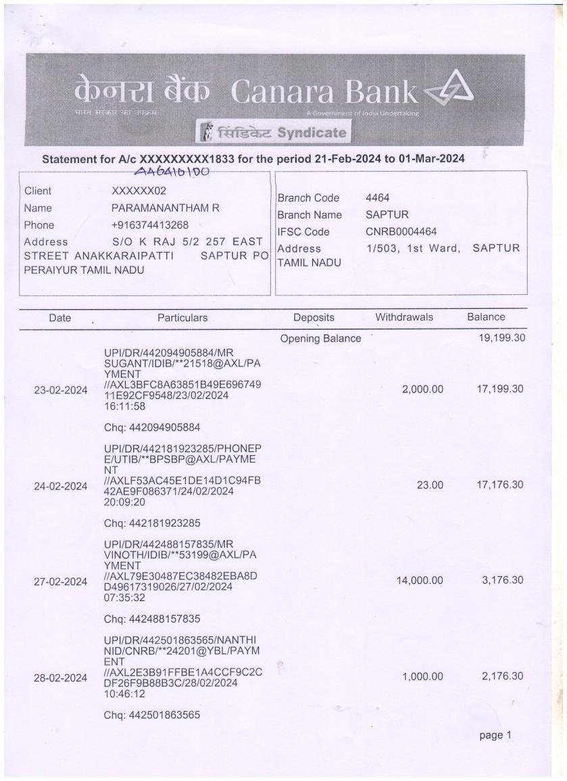
The Electricity bill more than 2 month older it should not be 45 days older

